Yuqing Zhang

* 1. Five variables with highest chi-square statistics with Loan_Default: marital_status, worst_credit_rating, inq_bank_promo, tot_accts_90days_ever, current_accts_90day.
  2. Five variables with highest worth score: risk_score, marital_status, tot_accts_paid_statis_24m, tot_accts_paid_statis, collection_items.
  3. Variables have missing observations: marital_status and income.

2.

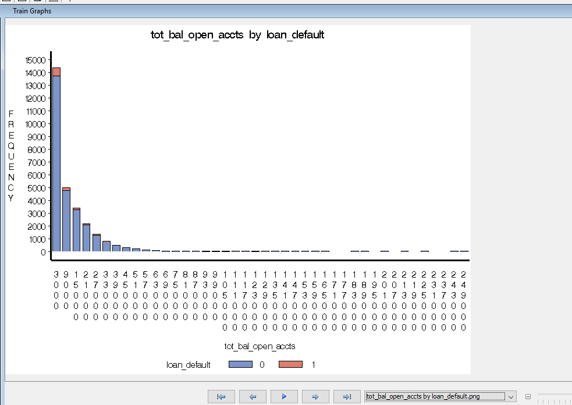

We can see in this chart, total balance on open accounts under 39000 makes up the majority. And people with less total balance on open accounts are more likely to have loan_default. People with total balance on open accounts under 3000 are most likely to have loan_deault.